***DEPARTMENTAL LIBRARY***

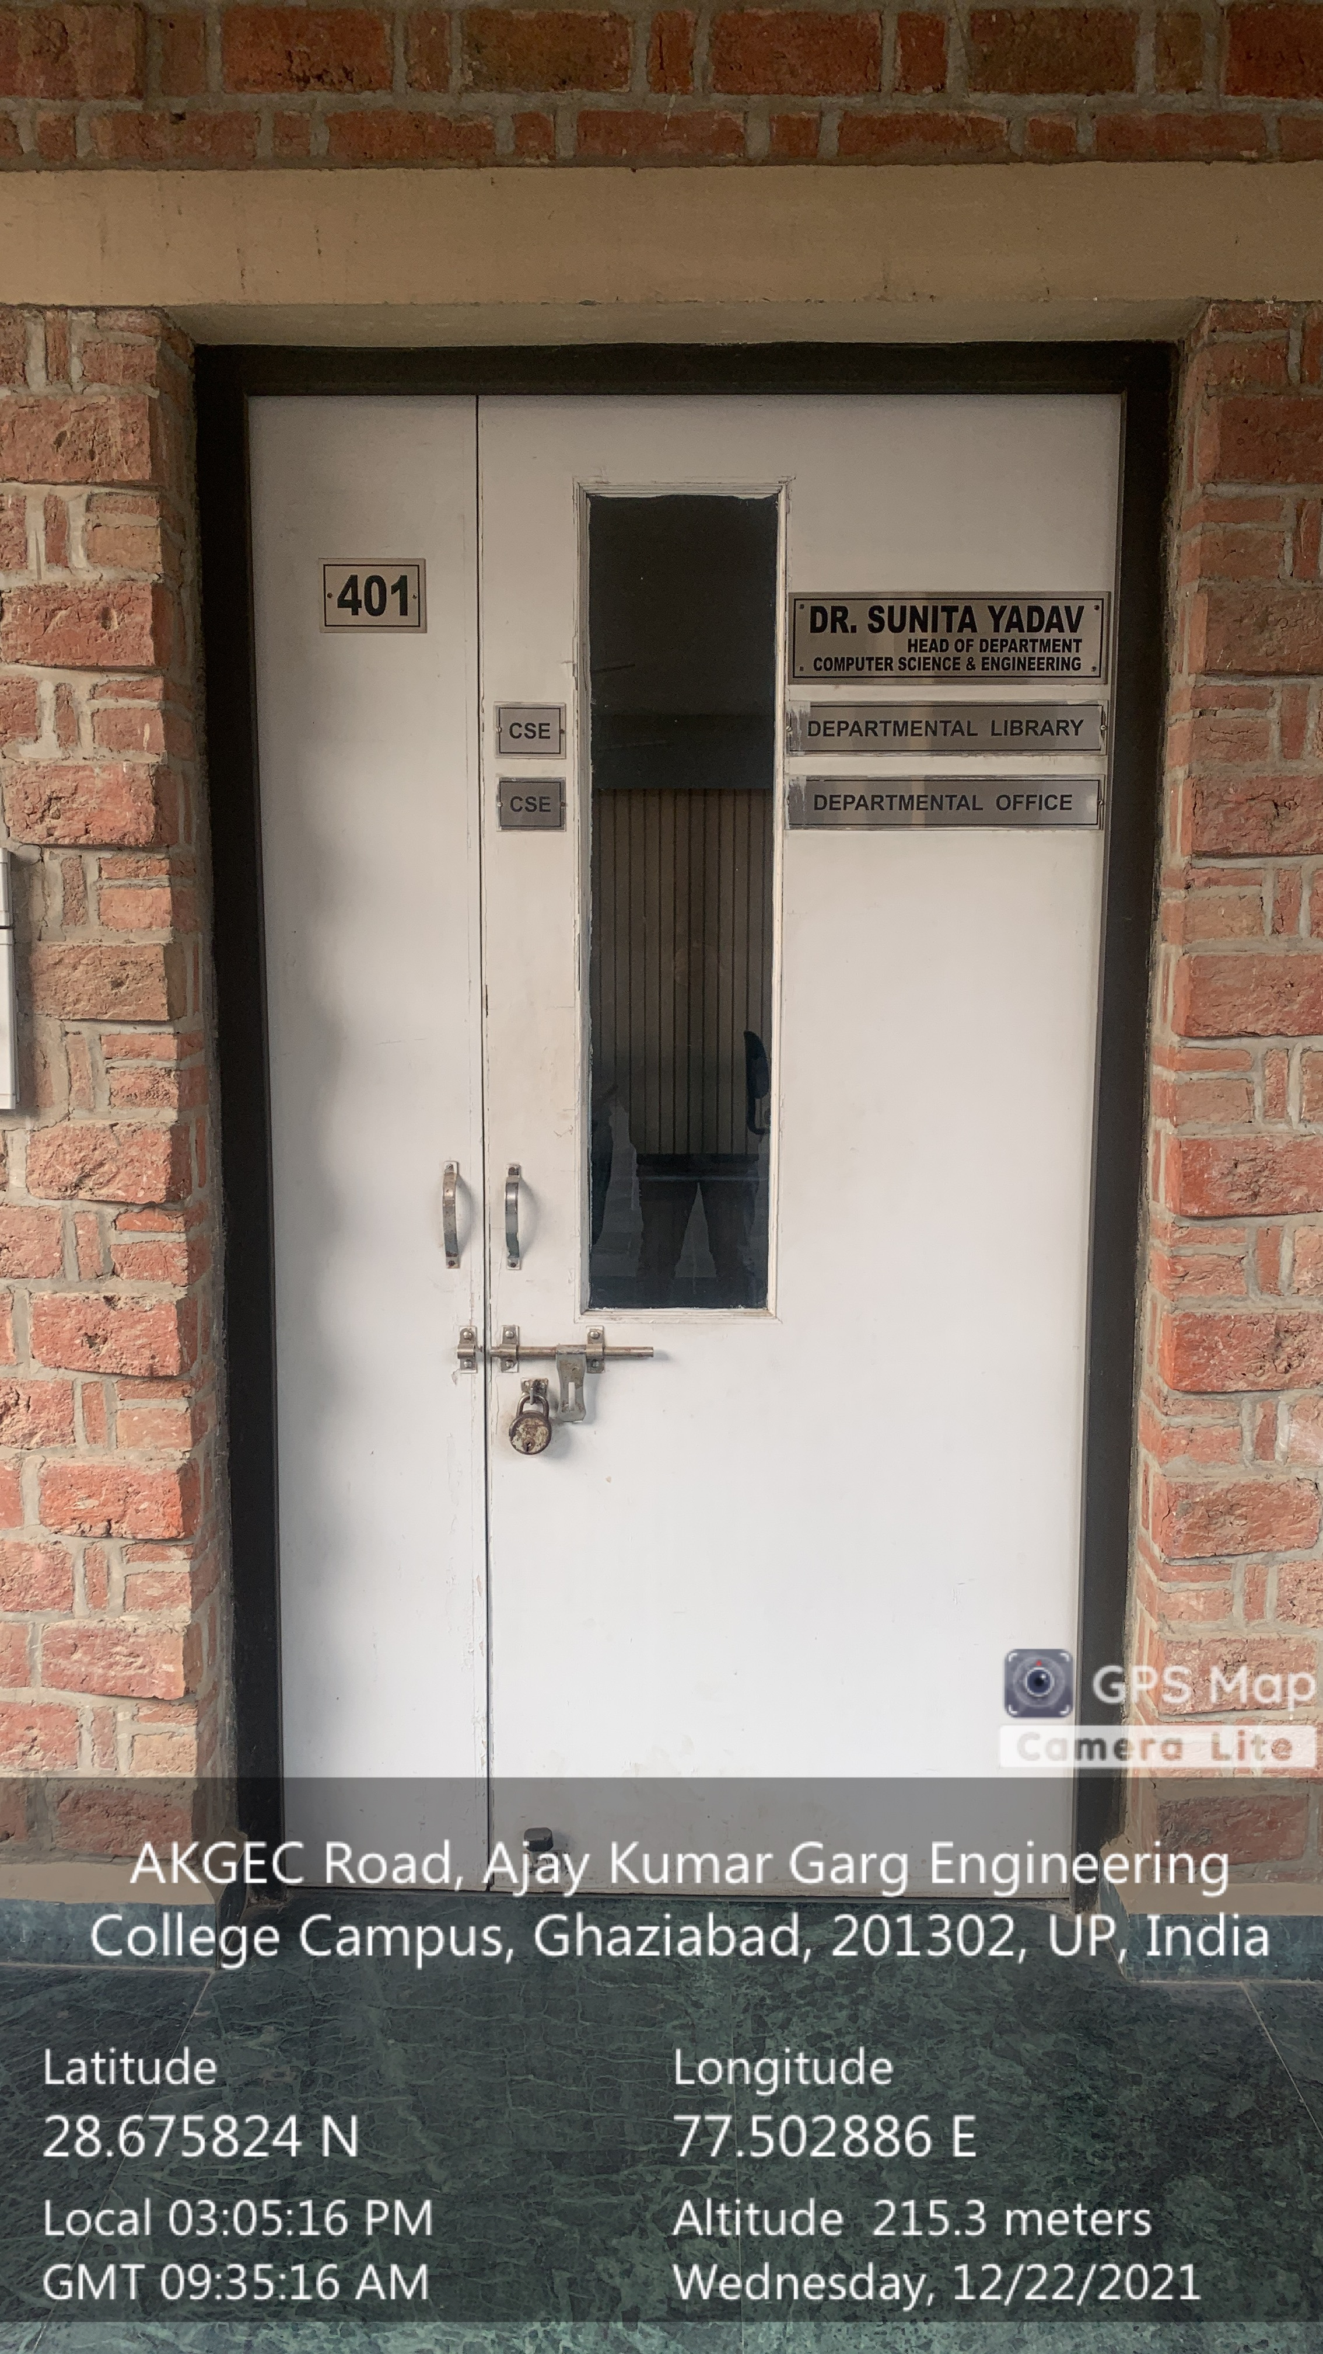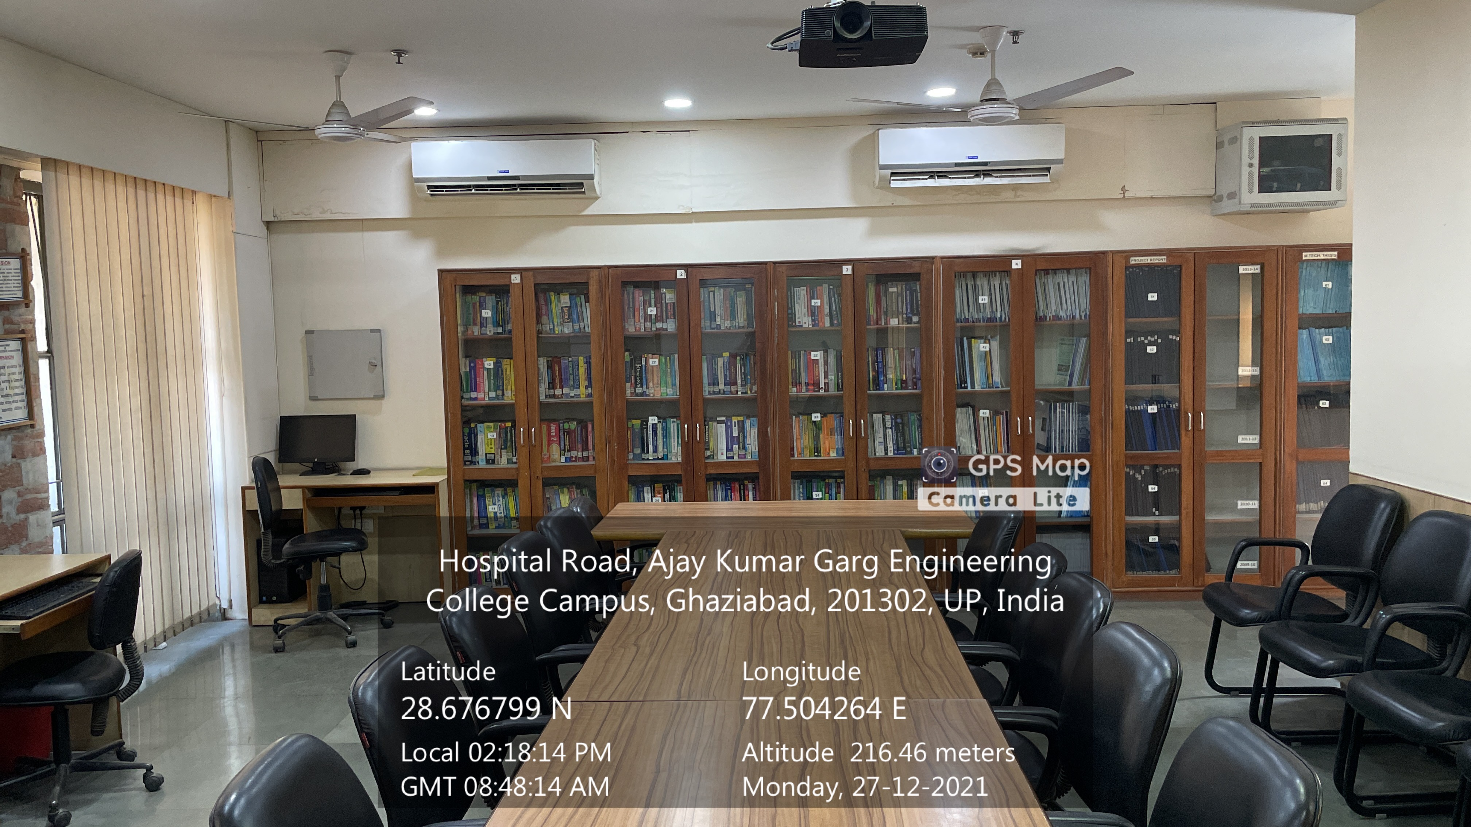

**Departmental Library (CSE)**

**(CSIT BLOCK, Fourth Floor)**

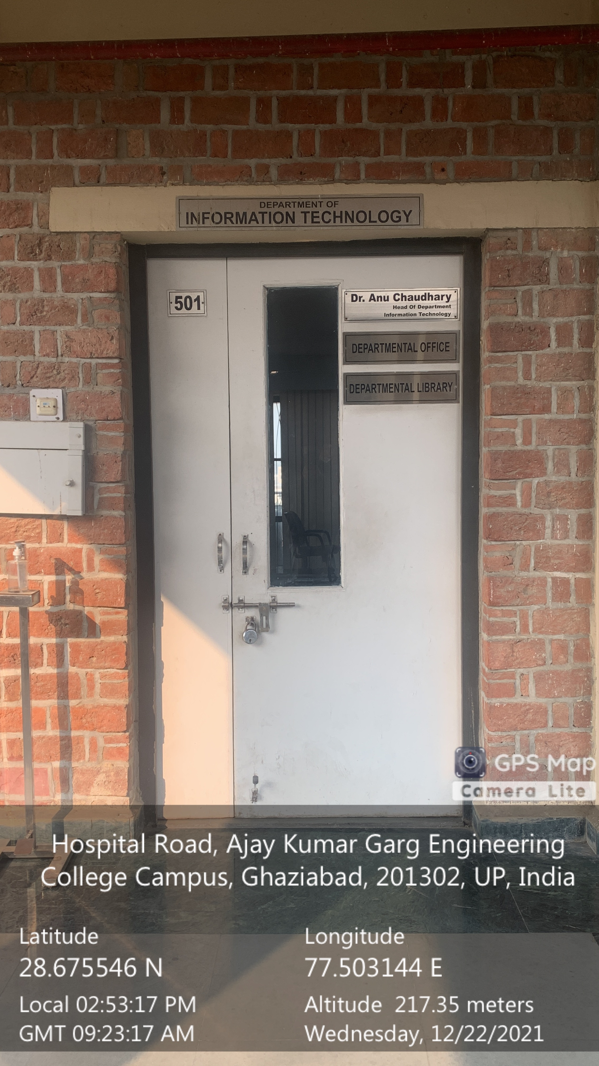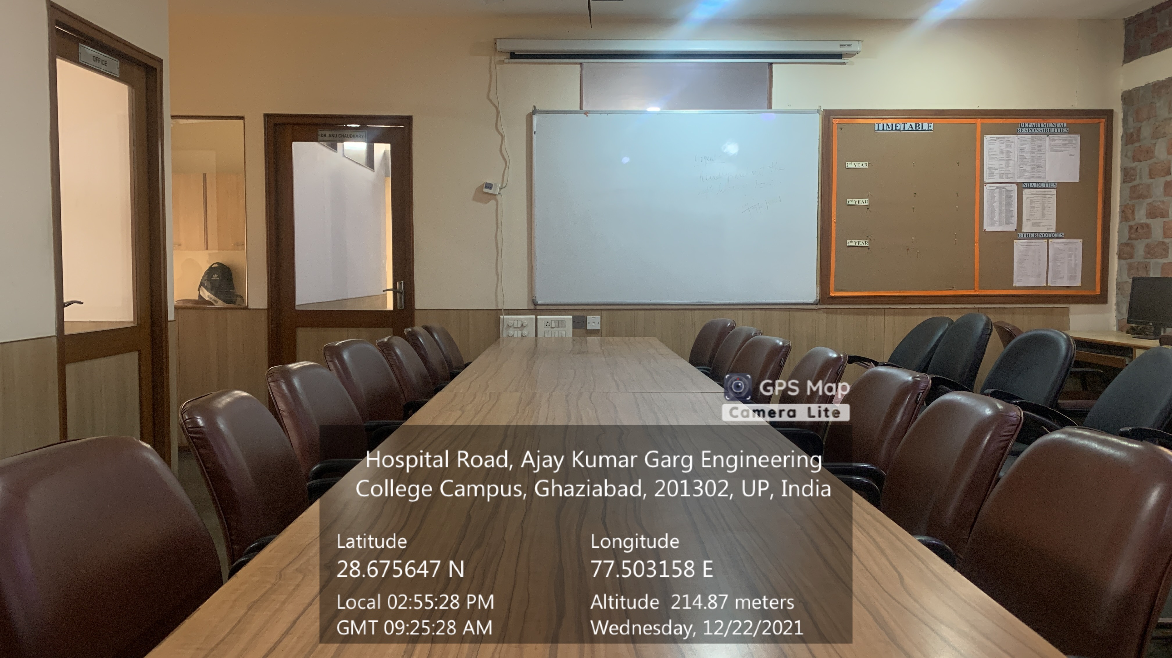

**Departmental Library (IT)**

**(CSIT BLOCK, Fifth Floor)**

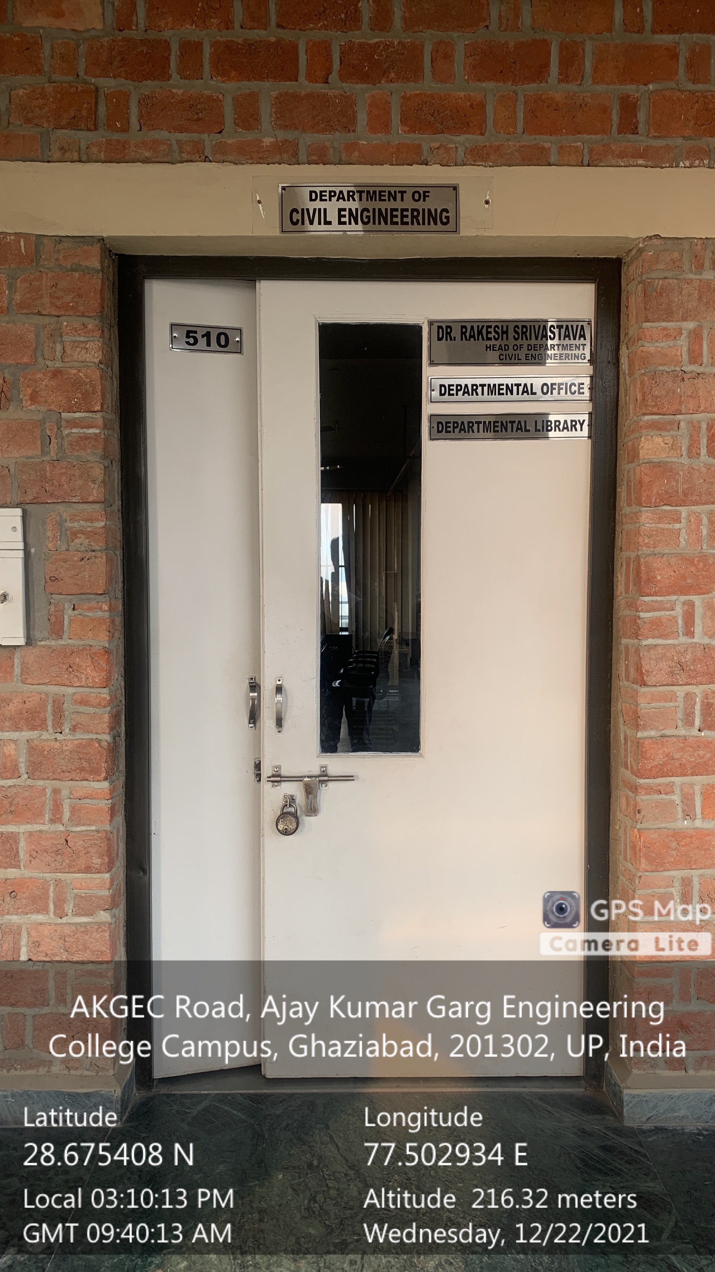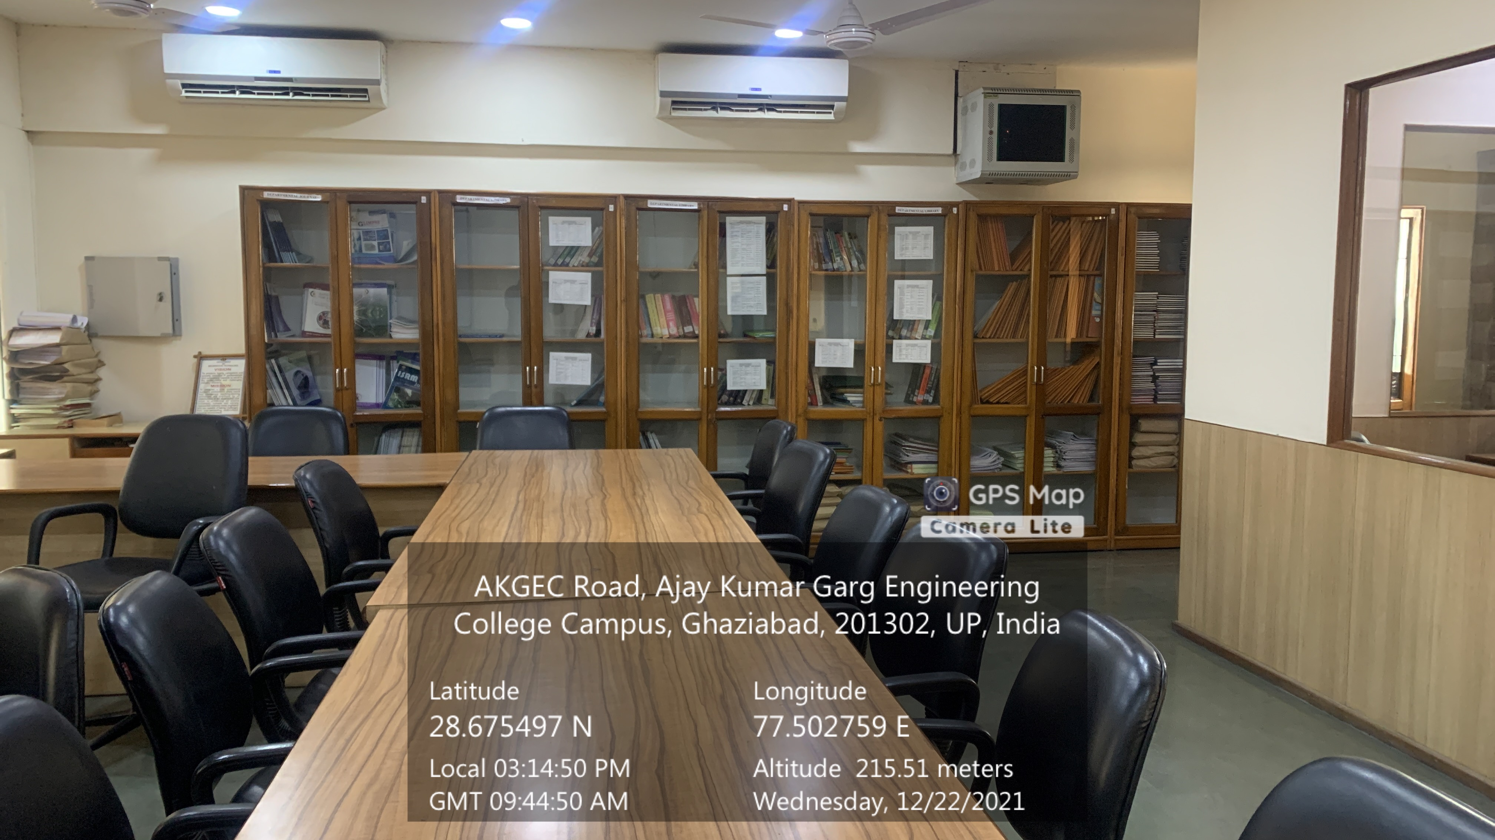

**Departmental Library (CE)**

**(CSIT BLOCK, Fifth Floor)**

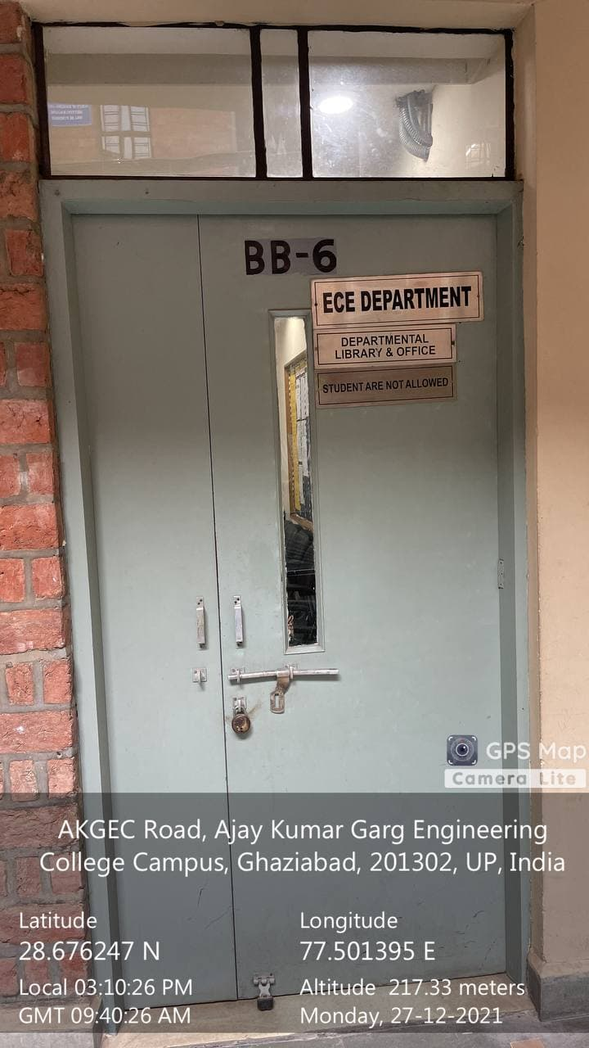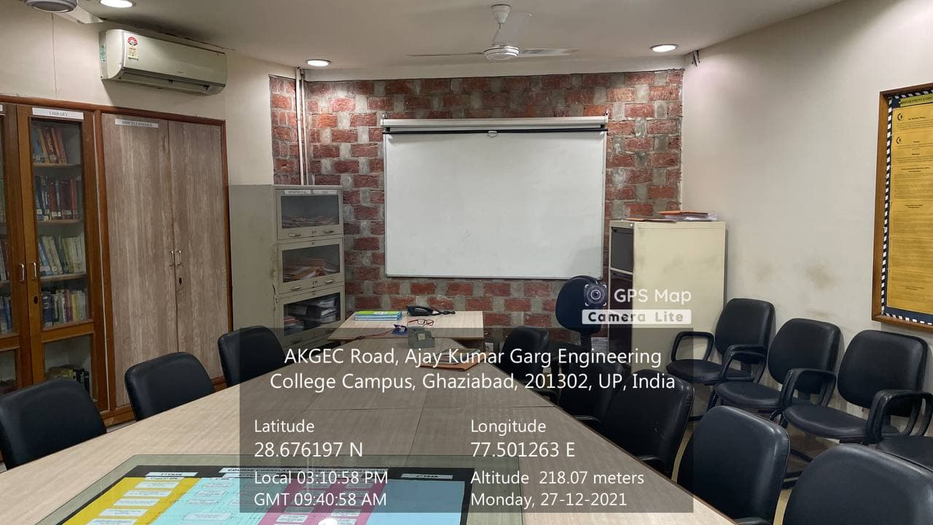

**Departmental Library (ECE)**

**(BB BLOCK, First Floor)**

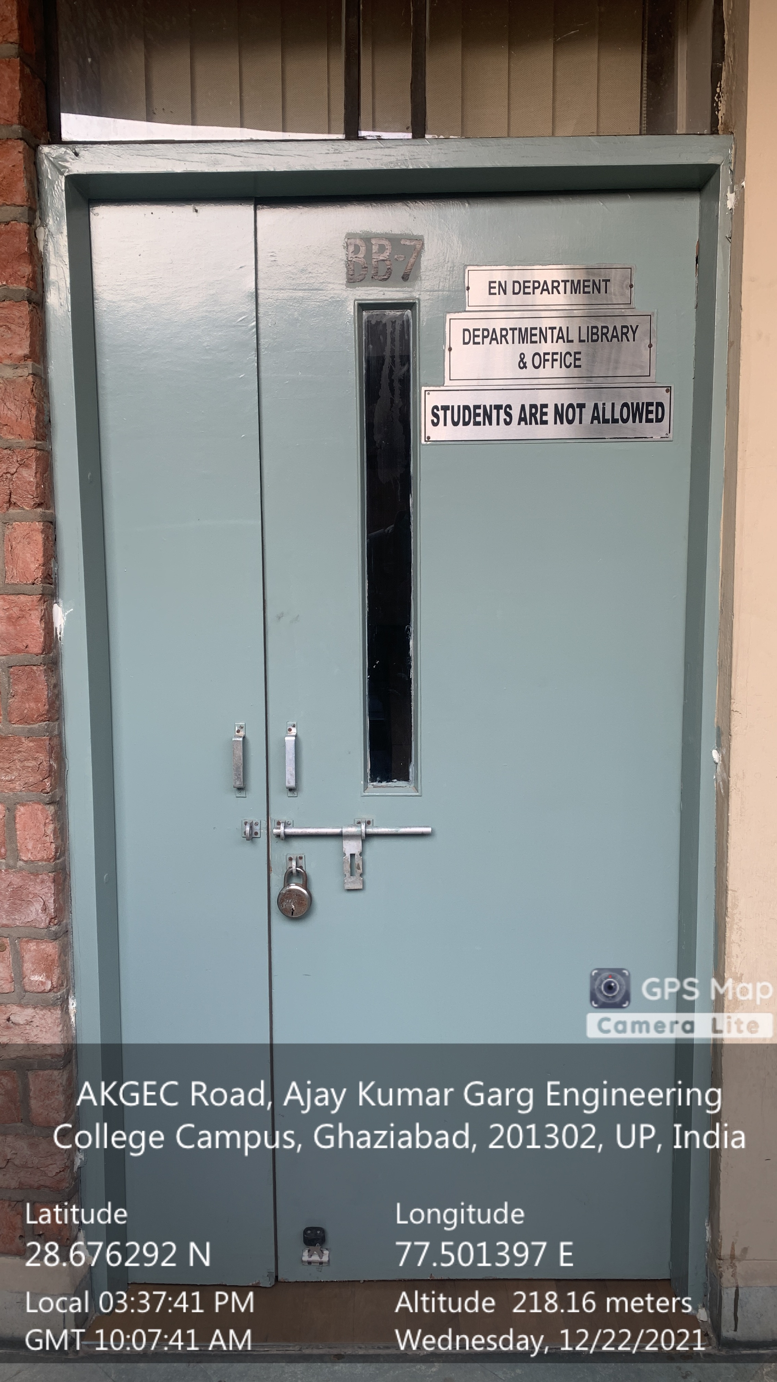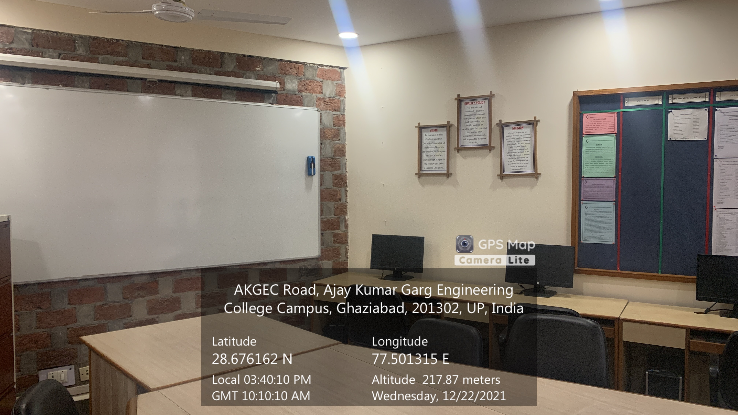

**Departmental Library (EEE)**

**(BB BLOCK, Second Floor)**

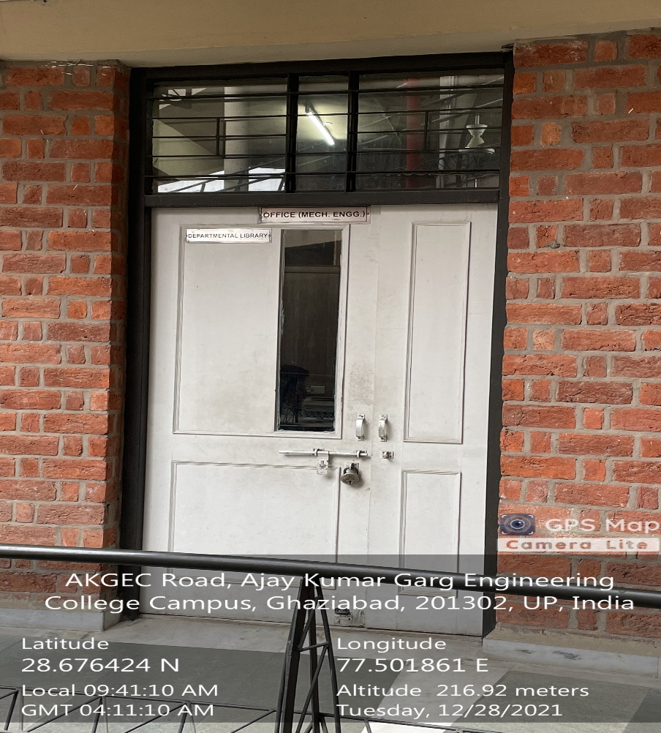

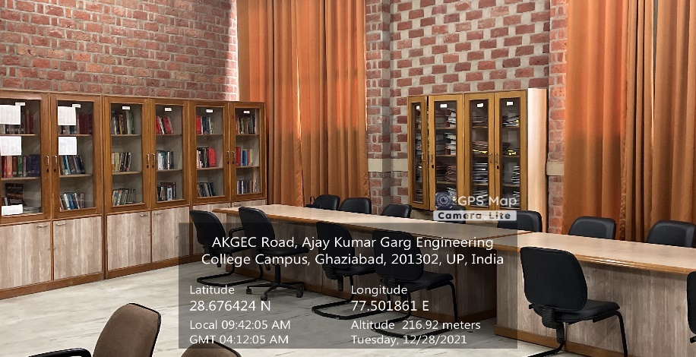

**Departmental Library (EEE)**

**(BB BLOCK, Second Floor)**

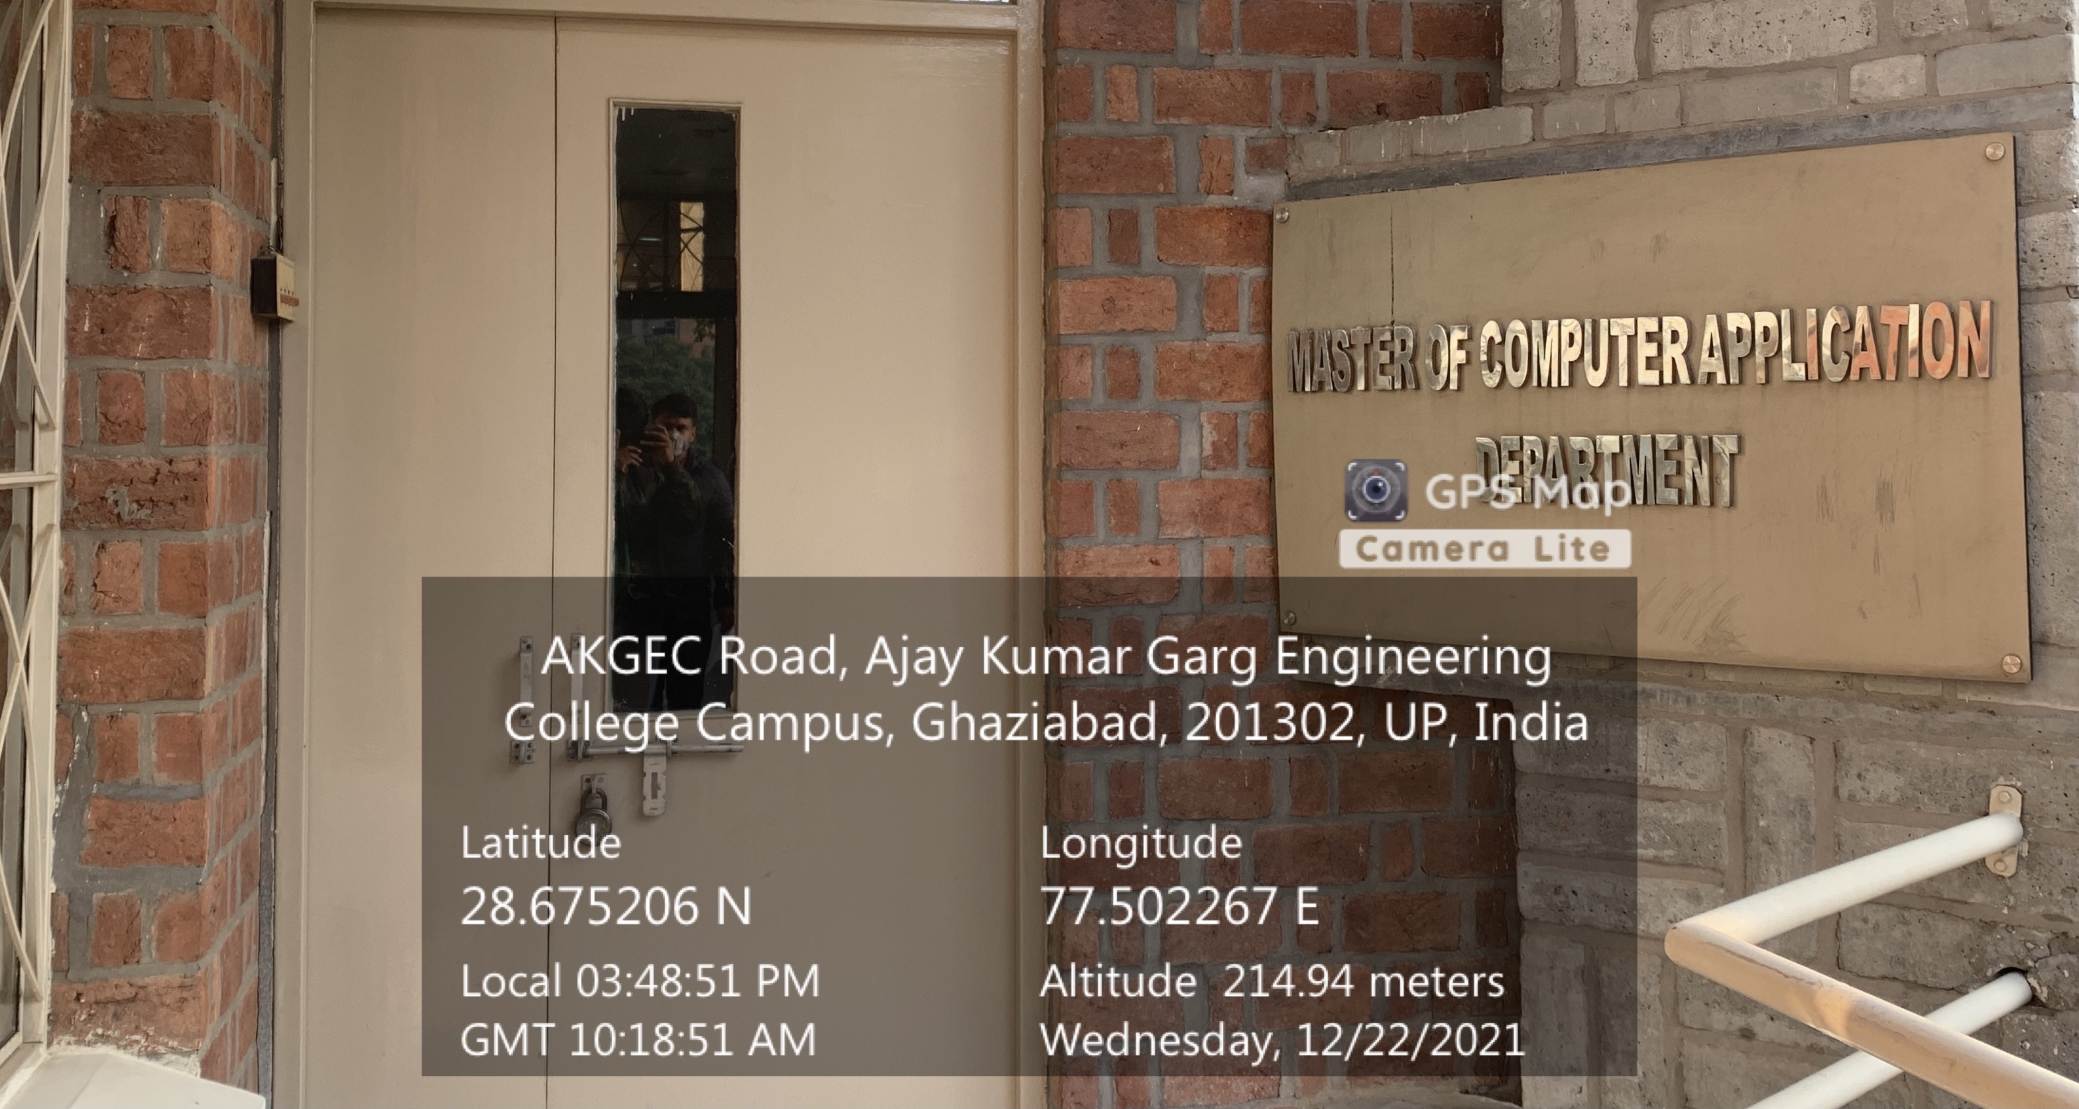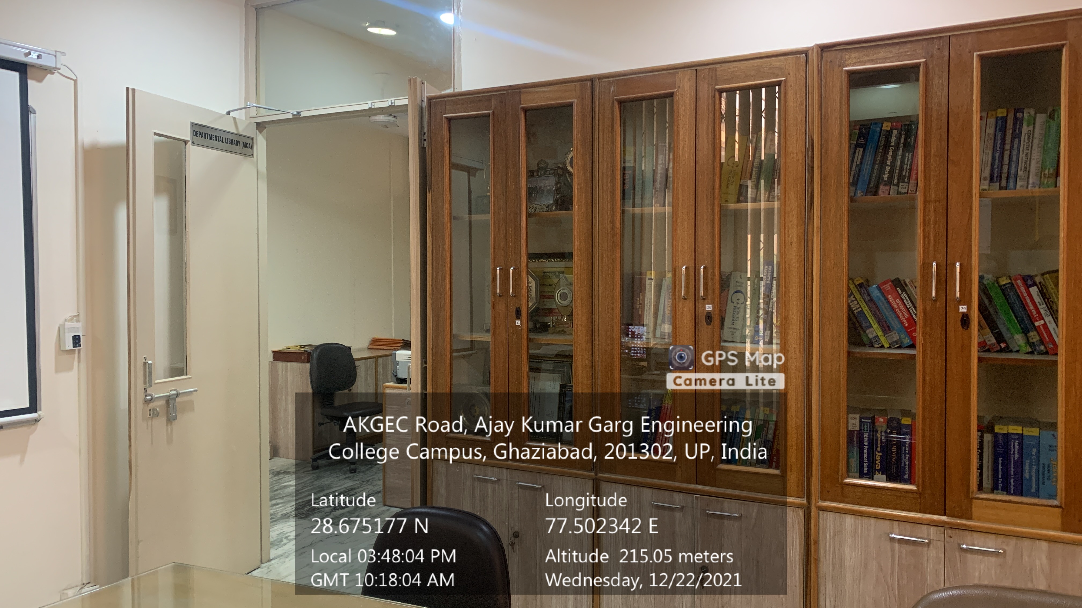

**Departmental Library (ME)**

**(MCA BLOCK, Second Floor)**